
Ux105 
Active Photocatalytic Oxidation Technology
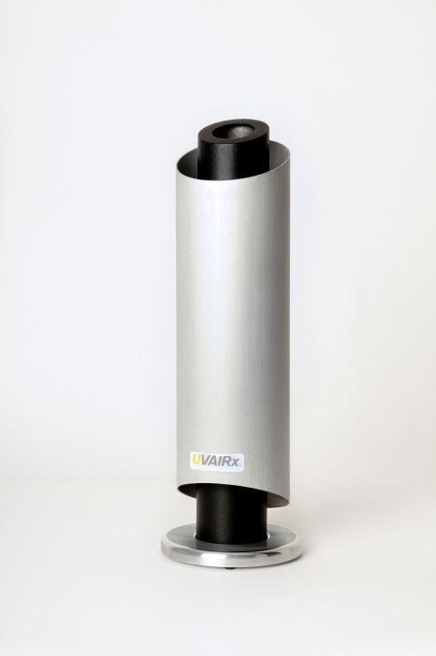
Destroys Airborne and Surface:
- Bacteria and Viruses
- Mold, Mildew and Fungus
- Odors
- Volatile Organic Compounds (VOCs)
- Smoke


The Ux105 is economical, low maintenance, light weight, compact and has versatile mounting options. It works 24/7, providing continuous disinfection others cannot. There are no filters to be changed. It is ideal for almost any indoor environment including, offices, doctor and dental offices, salons, pet kennels and groomers, veterinarians, restaurants, homes, and more!
Indoor air pollution is considered by the Environmental Protection Agency (EPA) to be the number one environmental health problem. Tightly sealed, energy efficient buildings and homes keep utility costs down but they also seal in pollutants and microbes causing odors, mold, and illnesses as well as aggravating allergies.
The UVAIRx Ux105 with its Active Photocatalytic Oxidation Technology (PCO) has been proven to drastically reduce airborne odors, VOCs, smoke, mold and fungus, bacteria and viruses over 90%. The Ux105 is effective on H1N1 (Swine Flu), Avian Influenza (Bird Flu), Norwalk, Methicillin Resistant Staphylococcus Aureus (MRSA), Streptococcus (Strep), E. coli and many viruses. Other pathogens that are mitigated include Listeria, E-Coli, Staph, and Streptococcus Pneumonia. Shown to be effective against COVID-19.
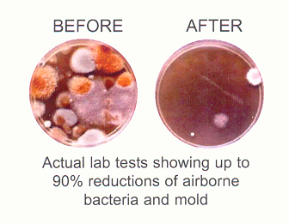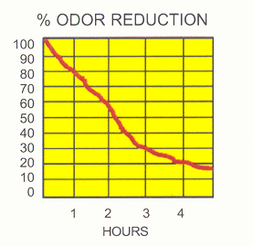
SPECIFICATIONS
Dimensions: | 16” h x 4”d
Electrical | 100 – 240 VAC input 12VDC 3.4A output
Weight | 3 lbs.
Material | Brushed Aluminum
The Technology:
The UVAIRx Ux105 utilizes Active Photocatalytic Oxidation Technology (PCO) in which a UV light is targeted on a proprietary hydrated, quad-metallic target which then creates super oxide ionized plasma consisting of oxidative clustered ions (OCIs). The resulting output reduces airborne mold, bacteria, VOCs and odors over 90%.
The PCO process is very efficient, using about the same energy as a standard 15 W light bulb and is designed to optimize that power consumption. Under normal conditions, the Ux105 PCO Cell should last up to 30 months, after which the Cell is easily replaced.

Active Photocatalytic Oxidation Technology is licensed for use in over 1 million individual devices globally in the medical, nursing and assisted living, home, companion pet, food retailing, military, beauty, residential, commercial, marine and hospitality industries.
PCO devices have been specified in the Norovirus and MRSA protection plan for some of America’s largest restaurant franchises, hotel chains, theme parks, cruise lines, public schools and hospitals. Away from Earth, PCO is deployed aboard the International Space Station.
The UVAIRx Ux105 carries a Limited Warranty for 24 months from the purchase of the device. Please see Owner’s Guide for details.

